

Healthcare Data Analysis and Insights from Multisource Medical Records

Graduation Project Group:
AST-Data Analyst Specialist-CAI3_DAT1_G3

Graduation Project members:
Bishoy Nasser Mosaad Yassa
Eman Rabea Mohamed
Menna Hatem Muatafa Ibrahim
Mohamed Ashraf Mahmoud Hasan
Sarah Ali Mansy
Somaia Ahmed Abdel Zaher Ali

Table of Contents Table of

- Project Title
- Introduction
- Objectives
- Dataset Description
- Methodology
- References

- Project Title

Healthcare Data Analysis of Patient Encounters and Organizations
- Introduction

Healthcare systems produce large amounts of structured data that, when analyzed, can reveal important insights. This project focuses on datasets covering patients, encounters, organizations, payers, and procedures. By applying data cleaning, exploratory analysis, and data modeling, the project aims to uncover trends in patient demographics, encounter types, medical costs, insurance coverage, and geographic distribution. The final outcome is an interactive Power BI dashboard that transforms raw data into meaningful information, supporting better decision-making in healthcare management.
- Objectives
Data Integration
• Combine multiple healthcare datasets (Encounters, Patients, Organizations, Payers, Procedures) into a unified model.
• Ensure consistency and accuracy through data cleaning and transformation.
• Exploratory Data Analysis (EDA)
• Perform statistical analysis to understand distributions and correlations.
• Identify meaningful patterns in patient demographics, encounter costs, and insurance coverage.
Data Modeling
• Design a star-schema model with Fact and Dimension tables.
• Establish relationships between tables to support efficient queries and reporting.
• KPI Development
• Define and calculate key performance indicators (KPIs) such as:
Total number of encounters, Total Procedures Cost, Average claim cost and Insurance coverage ratio.
Dashboard Creation
Build an interactive Power BI dashboard that visualizes:
- Patient demographics (age, gender, race, marital status).
- Encounter and claim costs.
- Insurance company comparisons.
- Geographic distribution of patients and organizations.
- Decision Support
- Provide healthcare stakeholders with actionable insights to improve resource allocation, reduce costs, and enhance patient care.
- Enable dynamic filtering and drill-down analysis for deeper exploration of the data.

- Dataset Description:
Encounters
Encounters Id, START, STOP, PATIENT, ORGANIZATION, PAYER, ENCOUNTERCLASS, CODE DESCRIPTION, BASE_ENCOUNTER_COST, TOTAL_CLAIM_COST, PAYER_COVERAGE
The Encounters data sheet records every patient encounter with healthcare organizations, capturing essential details about the encounter, participating entities, and associated financials. It is designed to support reporting, analytics, and auditing of patient interactions across multiple care settings.
Key fields and purpose
- encounters Id: A unique identifier for each encounter (UUID or sequential ID) to enable precise reference and updates.
- START: The start date/time of the encounter, used to determine duration and sequence.
- STOP: The end date/time of the encounter, used to determine duration and timeliness.
- PATIENT: An identifier for the patient involved in the encounter, linking to the patient record.
- ORGANIZATION: The organization or facility where the encounter occurred.
- PAYER: The payer or insurer responsible for coverage and claims.
- ENCOUNTERCLASS: The class/type of encounter (e.g., outpatient, inpatient, telemedicine, clinic) for classification and filtering.
- CODE DESCRIPTION: The description of the clinical code associated with the encounter (e.g., CPT/ICD description) to aid interpretation of services rendered.
- BASE_ENCOUNTER_COST: The base cost of the encounter prior to discounts, adjustments, or payments.
- TOTAL_CLAIM_COST: The total claimed amount after discounts and settlements; the final charge associated with the claim.
- PAYER_COVERAGE: The portion or amount covered by the payer, expressed as a percentage or monetary value, indicating patient liability after coverage.
Patients
Patients Id, BIRTHDATE, DEATH DATE, PREFIX, FIRST, LAST, SUFFIX, MAIDEN, MARITAL, RACE, ETHNICITY, GENDER, BIRTH PLACE, ADDRESS, CITY, STATE, COUNTY, ZIP, LAT, LON
The Patients data sheet contains demographic and identifying information for individuals receiving care. It supports patient contact, linkage with encounters, and demographic analytics. The structure is designed to enable accurate patient matching, reporting by demographics, and eligibility or risk analyses.
Key fields and purpose:
- Patients Id: A unique identifier for each patient to uniquely reference the patient across systems.
- BIRTHDATE: The patient’s date of birth (used for age calculations, eligibility, and risk stratification).
- DEATH DATE: The patient’s date of death, if applicable (used for lifecycle tracking and data governance).
- PREFIX: Honorific or name prefix (e.g., Mr., Mrs., Dr) for display purposes.
- FIRST: Patient's first/given name.
- LAST: Patient's last/family name.
- SUFFIX: Name suffix (e.g., Jr, III) for precise identification.
- MAIDEN: Maiden name, if applicable, particularly for historical records or matching.
- MARITAL: Marital status (e.g., SINGLE, MARRIED, DIVORCED).
- RACE: Self-identified race category.
- ETHNICITY: Self-identified ethnicity category.
- GENDER: Gender identity, with appropriate codes (e.g., M, F, U, Non-binary) as defined by your data standards.
- BIRTH PLACE: Place of birth (city/state/country) for demographic analyses.
- ADDRESS: Street address for contact and eligibility checks.
- CITY: City of residence.
- STATE: State/region of residence.
- COUNTY: County of residence.
- ZIP: Postal/ZIP code for location-based analytics and matching.
- LAT: Latitude coordinate of the patient’s primary residence (optional geospatial data for analyses).
- LON: Longitude coordinate of the patient’s primary residence (optional geospatial data for analyses).
Organizations
Id, NAME, ADDRESS, CITY, STATE, ZIP, LAT, LON
The Organizations data sheet records basic contact and location details for organizations involved in care delivery or administration. It supports linking to patient encounters, payer records, and staffing or referral workflows, as well as geographical analyses.
Key fields and purpose:
- Id: A unique identifier for each organization (UUID or sequential ID) to enable precise reference and updates.
- NAME: Official name of the organization.
- ADDRESS: Street address for contact and verification.
- CITY: City where the organization is located.
- STATE: State or region.
- ZIP: Postal or ZIP code for location-based analyses and mailings.
- LAT: Latitude coordinate of the organization’s address (optional geospatial data).
- LON: Longitude coordinate of the organization’s address (optional geospatial data).

Payers
Id, NAME, ADDRESS, CITY, STATE_HEADQUARTERED, ZIP, PHONE
The Payers data sheet captures essential contact and location details for payer organizations (e.g., health insurers, government programs). It supports billing, claims processing, and provider directory accuracy, and it can be linked to encounters and patient records for coverage validation and analytics.
Key fields and purpose:
- Id: A unique identifier for each payer to enable precise reference and updates.
- NAME: Official name of the payer organization.
- ADDRESS: Street address for contact and verification.
- CITY: City where the payer is headquartered or located.
- STATE_HEADQUARTERED: State or region where the payer is headquartered (useful for governance and segmentation).
- ZIP: Postal/ZIP code for location-based analyses and mailings.
- PHONE: Main contact phone number for the payer.
Procedures
The Procedures data sheet records individual procedural steps or interventions associated with patient encounters. It links each procedure to the corresponding patient and encounter and captures the basic cost information for budgeting, billing, and analytics.
Key fields and purpose:
- Procedures START: The start date/time of the procedure.
- STOP: The end date/time of the procedure.
- PATIENT: A unique identifier for the patient undergoing the procedure.
- ENCOUNTER: The related encounter ID to link the procedure to a specific patient encounter.
- CODE DESCRIPTION: The clinical code and description for the procedure (e.g., CPT/ICD-PCS descriptions) to aid interpretation and coding accuracy.
- BASE_COST: The base cost of the procedure before discounts, adjustments, or payments.

- Methodology:
Step (1) – Data Cleaning (Python)
Data cleaning is a critical step to ensure the dataset is reliable, consistent, and ready for modeling and visualization. In Power Query, the following operations are typically performed:
1. Remove Duplicates, Nulls, and Blanks
- Identify and eliminate duplicate rows to avoid double counting.
- Detect and handle null or blank values to prevent errors in calculations.
- Decide whether to remove these records or replace them with appropriate values depending on business logic.

df.head()
df.tail()
df.info()
df.describe()
df.dtypes

dd.head()
dd.tail()
dd.info()
dd.describe()

ds.head()
ds.tail()
ds.info()
ds.describe()

2. Edit Numeric Values
• Standardize numeric formats by removing commas, correcting negative signs, and ensuring consistent decimal points.
• Convert text-based numbers into proper numeric data types.
• Validate ranges (e.g., ages, prices, medical values) to ensure they fall within acceptable limits.
df['BIRTHDATE'] = pd.to_datetime(df['BIRTHDATE'], errors='coerce')
df['DEATHDATE'] = pd.to_datetime(df['DEATHDATE'], errors='coerce')

dd['START'] = pd.to_datetime(dd['START'], errors='coerce')
dd['STOP'] = pd.to_datetime(dd['STOP'], errors='coerce')

ds['START'] = pd.to_datetime(ds['START'], errors='coerce')
ds['STOP'] = pd.to_datetime(ds['STOP'], errors='coerce')

3. Standardize String Values
- Apply text transformation functions to unify formatting across categorical fields.
- Common functions include:
→ remove leading/trailing spaces
→ convert text to uppercase
→ convert text to lowercase
→ capitalize first letter of each word
- Replace inconsistent spellings or abbreviations with standardized values.

4. Format Dates and Other Data Types
- Convert all date fields into a consistent format.
- Ensure time fields are properly recognized as datetime types.
- Align formats across different sources to avoid mismatches in relationships or calculations.

5. Delete Unnecessary Columns
- Remove columns that are irrelevant to the analysis or KPIs.
- Drop temporary or technical fields (e.g., IDs used only for import, notes, or metadata).
- Keep only the attributes that contribute to the business logic and reporting.

6. Handle Missing Data
- Decide on a strategy for missing values:
- Deletion → remove records with excessive missing data.
- Imputation → replace missing numeric values with mean/median, and categorical values with the most frequent category.
- Document the chosen approach to maintain transparency in the data preparation process.
7. Apply Transformation Functions
- Use Power Query functions to enforce consistency:
→ clean spaces
→ unify text case
→ substitute incorrect or outdated values
→ unify numeric or date formats
- Ensure transformations are applied systematically across all relevant columns.

8. Validation After Cleaning
- Re-check the dataset to confirm:
- No duplicates remain.
- Data types are consistent.
- Missing values are handled according to the defined strategy.
- Columns align with the analysis requirements.
Step (2) – Exploratory Data Analysis (EDA) (Python)
EDA is the process of exploring the dataset to understand its structure, detect patterns, and identify anomalies. It provides the foundation for modeling and dashboard design.

1. Descriptive Statistics
Goal: Summarize the dataset numerically to understand distributions.
What to include:
- Mean → average value (e.g., average patient age).
- Median → middle value (useful when data is skewed).
- Standard Deviation (SD) → spread of values around the mean.
- Variance → measure of variability.
- Mode → most frequent value (e.g., most common diagnosis).
- Count → number of records per column.
Why it matters: Helps you quickly see if data is balanced or skewed (e.g., more diabetic patients than hypertensive ones).
2. Outlier Detection
Purpose: Detect unusual values that may distort analysis.
Methods:
- Boxplot visualization → shows median, quartiles, and outliers.
- Z-score method → values beyond ±3 SD.
- IQR method → values outside Q1 − 1.5×IQR or Q3 + 1.5×IQR.
3. Documentation of Findings
Record insights such as:
- Distribution of patient ages and medical values.
- Correlations (e.g., Age ↔ Blood Pressure).
- Outliers (e.g., extremely high cholesterol).
- Any anomalies or missing data patterns.
These findings guide Data Modeling and ensure transparency in the project

Step (3) – Data Modeling (Power BI)
Data modeling is the process of structuring the dataset into a logical framework that supports analysis and visualization. In this step, the tables are renamed and relationships are defined to ensure clarity and consistency.
1. Edit Table Names
Purpose: Standardize naming conventions to distinguish between fact and dimension tables.
Approach:
Transactional tables are renamed as Fact tables.
Example: Fact_encounters → contains encounter-level data (procedures, patients, payers, organizations).
Reference tables are renamed as Dim tables.
Example: DIM_patients, DIM _counters
Benefit: Clear separation between transactional data (facts) and descriptive attributes (dimensions), making the model easier to understand and maintain.
2. Define Relationships Between Tables
Purpose: Establish logical connections between fact and dimension tables to enable filtering and aggregation
The image below illustrates the star schema used in Power BI, where the central fact table is connected to multiple dimension tables through key relationships:
Each relationship is defined as many-to-one (*:1) and is active, allowing filters from dimension tables to propagate correctly to the fact table. This setup enables:
- Filtering encounters by procedure type, organization, patient demographics, or payer.
- Aggregating KPIs such as total encounters, average cost, or patient count per category.
- Building slicers and drill-through visuals that respond dynamically to user selections.
- Ensuring referential integrity between transactional data and descriptive attributes.
These relationships form the backbone of the analytical model and ensure that all measures and visuals reflect accurate, context-aware insights.
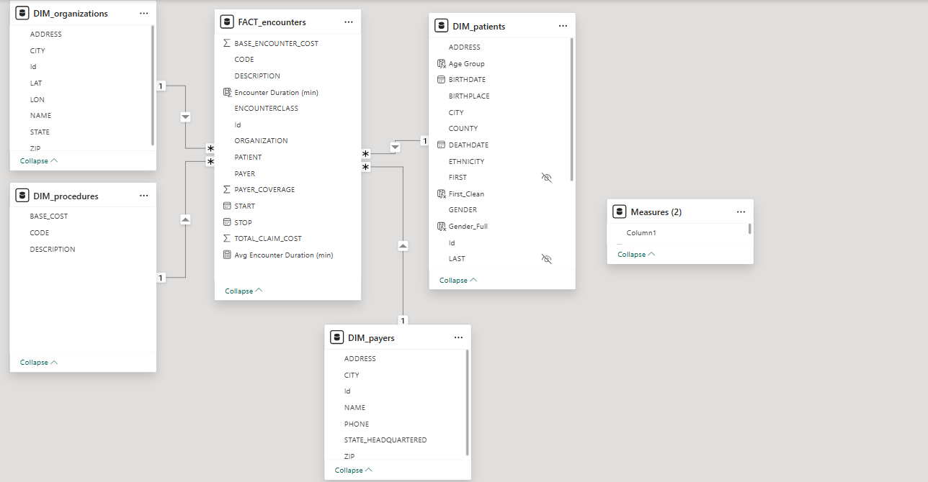

Step (4): Add Necessary DAX Measures → Build Dashboard (Report)
Adding DAX Measures
Purpose: To create calculated measures using DAX (Data Analysis Expressions) that provide accurate performance indicators for analysis within the report.
Process: Identify the key performance indicators (KPIs) required, such as:
- Total Encounter Cost
- Average Claim by Payer
- Most Common Procedure
- Average Payer Coverage Percentage
Write DAX formulas for each KPI, for example:

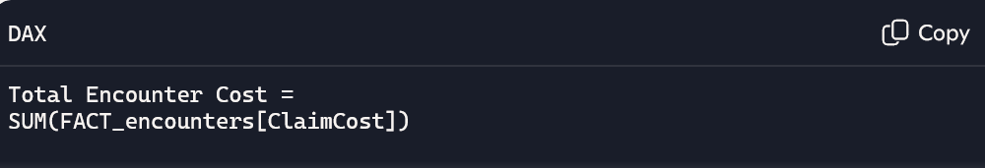

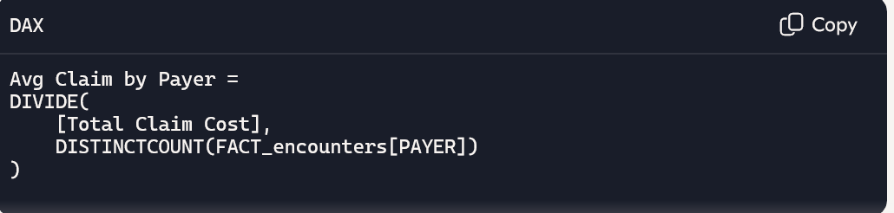
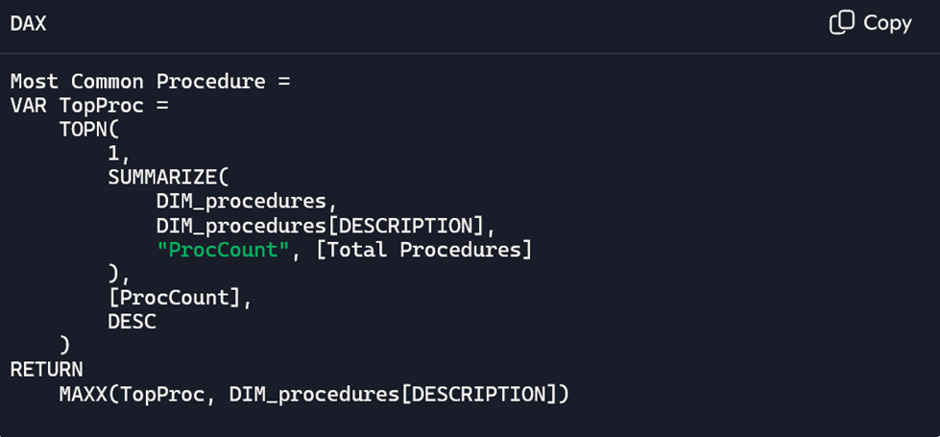


Dashboard Design
The dashboard was structured to deliver a professional, interactive, and user‑oriented interface tailored for medical analytics. Key performance indicators were emphasized through KPI cards and dynamic charts. Slicers and filters were integrated to allow flexible exploration of data across departments and time periods. The overall layout provides a concise overview of essential healthcare metrics while enabling detailed drill‑down analysis at the departmental level, ensuring clarity, consistency, and effective decision‑making support.
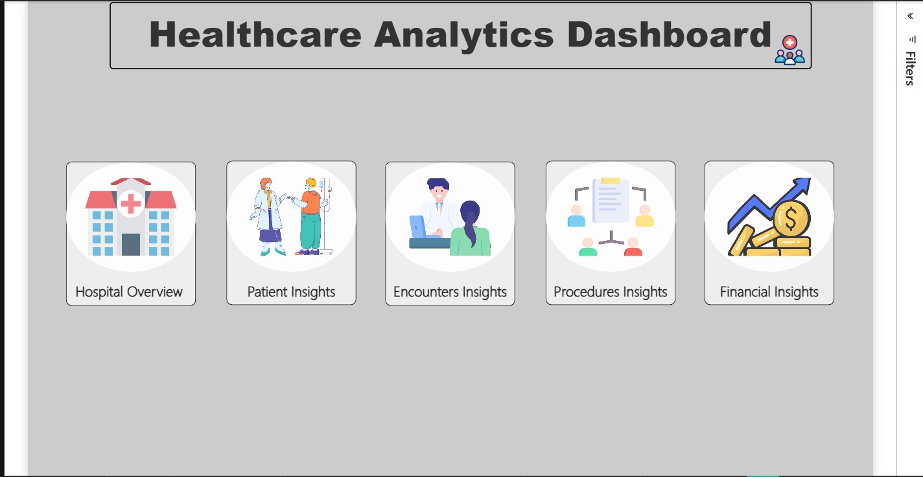

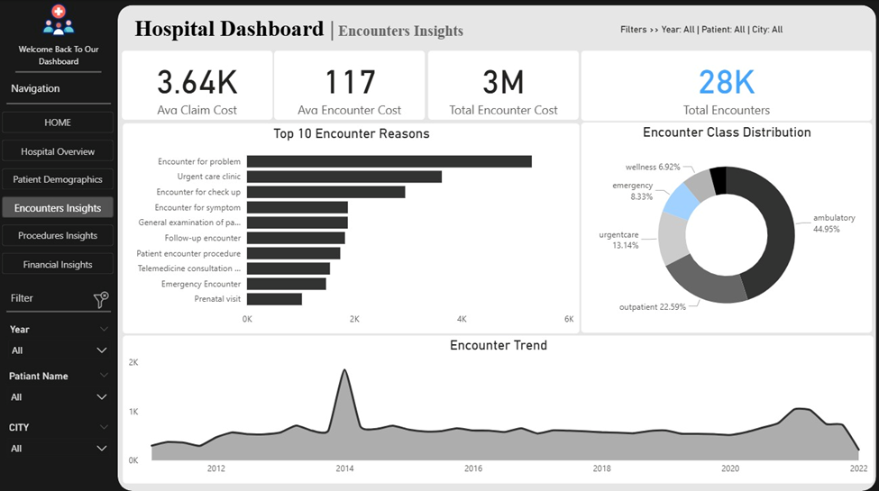
6.References
https://colab.research.google.com/drive/1vAg2s6W8CRx_3kIs4ahp6z-xPggNI0i7#scrollTo=pKoENniVjvBk
https://mavenanalytics.io/data-playground/hospital-patient-records?utm_source=chatgpt.com

